**Deep Learning for Image Scene Classification**

# **Introduction**

Deep learning, one of the most prominent subsets of machine learning, have become one of the popular ones due to its astounding achievements in numerous areas for example, computer vision and natural language processing as well as speech recognition. Having the power of top-notch hardware and tremendous data sets, deep learning solves complicated problems which were before considered difficult or stunning.

Of the areas of applications for deep learning is image scene classification where deep network has been trained to categorize of image or determine what is in the image based on its visual features. The scope of this task spans numerous areas including robotic driving, surveillance, environment monitoring, and many others.

# **Background and Context**

The Intel Image Classification dataset used for deep learning was initially published by Intel on a data science platform. It includes several thousands of images that represent natural scenes from different parts of the world taken with various cameras. The dataset is divided into six categories: architectural, vegetative, aquatic, alpine, glacial, fluvial, lithic. The challenge entails developing a deep learning model able to classify these pictures with high accuracy.

Considering that the content of scenes is heterogeneous, it is especially significant that the model utilized has been specifically developed for the purposes of classification and should be able to detect high-level visual patterns. Non-Convolutional Neural Networks (CNNs) in which hierarchical features are learned through a way have become the ones with the big popularity in this kind of tasks.

## **Problem Statement and Objectives**

The goal of this undertaking is to fabricate, incorporate and evaluate the given deep learning model based on image scene classification using the Intel Image Classification dataset. The specific goals are:

1. This project proposes to layer a Convolutional Neural Network (CNN) that will classify images into the given categories with great precision.
2. To understand the contingency and difficulties deep learning in regards to image scene classification.
3. This way, the suitability of the model can be assessed by comparing prognosis to actual outcomes in order to minimize any form of flaws and as such, necessary changes made to advance the model's efficiency.

By means of this project, we intend to look into the most potent deep learning techniques and evaluate them in order to determine whether they are capable of addressing actual classification challenges.

## **Overview of Deep Learning Applications**

Deep learning has enabled many industries with its richness of processing and extracting knowledge from large data set in an effective way. undefined

* **Healthcare:** In the case of medical image analysis, like in the example of tumour detection in MRI scans or abnormality inspection in X-rays, respectively.
* **Transportation:** Through smart sensors, the AV will be able to understand the pedestrians, other vehicles, and road settings.
* **Security:** For monitoring and surveillance correction of the suspicious activities that could appear automatically.

The scope of this project is concentrated on utilizing deep learning in image scene classification that features great importance in diverse fields. With the use of the deep learning approach, we can enhance the models which are able to develop the progress in different areas.

# **Literature Review**

Deep learning has quickly grown to be the primary technique of computer vision having a broad range of applications from image classification through orientation to segmentation. This review of the literature investigates several recent developments in the deep learning area for computer vision by considering, among others, parameterized techniques and their models as well as the existing solutions and the associated limitations.

## **Overview of Recent Developments in Deep Learning for Computer Vision**

In recent years, CNNs especially have been mainly behind progress in deep learning and this revolution in computer vision. One of CNNs' main abilities is to automatically learn features from unprocessed picture data and act better than anything else at image classification, object detection, and image segmentation. Due to the crowding of big data and strong GPUs has been initiated the evolution of deep learning models at a much higher pace.

## **Key State-of-the-Art Techniques and Models**

Several key techniques and models have shaped the landscape of deep learning in computer vision:

* **Convolutional Neural Networks (CNN):** CNNs are sophisticated deep learning techniques used in image and video processing. They employ convolutional layers to extract features of images with hierarchical nature – horizontal and vertical levels layers are used to reduce dimensionality. Ace CNN models such as LeNet, AlexNet, VGG, and ResNet are celebrated (Cheng et al., 2020). These models were able to do very well at tasks like picture classification and identifying objects quite well too.
* **Generative Adversarial Networks (GANs):** GANs, introduced by Goodfellow et al., consist of two networks: These comprise of either a generator or a discriminator. A neural network comprises a generator, which manifests the images and the evaluator (discriminator), which reviews them. Unlike GANs, adversarial approaches offer a way to generate more realistic images and they have important application areas in data augmentation and image translation (Han et al., 2018).
* **Recurrent Neural Networks (RNNs)** and the LSTM RNN are the neural networks for sequential data that in its turn is mostly used in natural language processing. Computer vision contexts are specifically designed in order to capture the temporal rules of the sequences; therefore, it becomes possible to use artificial intelligence applications like video analysis and recognized activities (Gu et al., 2019).

Attention Mechanism Attention mechanisms make neural networks to focus their attention to particular areas of the image, thus improving the quality of the information captured. These methods are obviously accompanied with the other models by the Transformers type, which benefit in the tasks where an image should be detected and captioned (Ma et al., 2021).

## **Discussion of Existing Solutions and Their Limitations**

While deep learning has made significant strides, there are still limitations and challenges that researchers are addressing:

* Data Dependence A key characteristic of deep learning networks is that they depend heavily on labeled, large volumes of data for optimum performance in their training. This becomes, however, a problem in some areas that are poor in labeled data as the models tend to overfit and lack generalization (Zeng et al., 2000).
* Computational Load The computational load for training deep learning models might be high, and as a result, it has necessitated GPUs or TPUs since they are the specialized hardware applications. This obstacle prevents smaller research organization or individual programmers to employ artificial intelligence (AI) in their automation projects due to cost.
* Factors such as explainability and interpretability that are a constant concern especially in that the most advanced type of DNN that is considered to be a black box. Noticing that how they work and how exactly they fail are real challenges for implementation in healthcare and security is one of their biggest obstacles (Xu et al., 2020).

# **Dataset and Data Preparation**

The dataset that I used for the project is the Intel Image Classification dataset which is composed of images of natural scenes from different parts of the world. The dataset is divided into six categories: buildings, green lawn, glacier, mountain, sea, and street. This different range of images offers a system of training and test for understanding and developing deep learning models which are being used for scene classification including the life structure such as nature or man-made structure. The data-set consists of the minimal size images of 150x150 pixels with the number of images approximately 25,000. This provides us perfect control over the image processing and computational operations.

## **Data Loading and Preprocessing**

In loading the dataset, however, the images had to be first extracted from the compressed files into folders for training and testing. In each folder image will be arranged by a class, this will help, if the future user needs to quickly map the images files with their classes.

The data preprocessing involved several key steps to prepare the images for training with a Convolutional Neural Network (CNN):

* **Resizing:** For all images the size was reduced to 150x150 pixels to allow for the neural network to take in inputs of given dimensions.
* **Normalization:** Pixel values were scaled from 0-255 to 0-1 by getting the division by 255. This normalization part helps better model's training by improving the convergence.
* **One-Hot Encoding:** The class labels, which were given as the names of categories at the start, were turned to one-hot encoded vectors. The development is obligatory for multi-class classification that generates a probability distribution on six classes.

# **Training and Validation**

The training and validation part is significant in delicate design and redesign of a deep learning model for image classification. In this section, the training process and steps taken, such as training parameters set up and use of validation data and evaluation metrics for measuring the model performance, will be described. It is also featured to let the user see how the history of the training curls around a wing that shows the accuracy and loss through epochs.

## **Training Process**

The training process works by the model being given test sets, over which it learns its underlying patterns and relations. For this project, the training process was configured with the following parameters:

* **Epochs:** We trained the model for a total of ten seasons. Epoch refers to the number of full instances where the network makes a pass over the entire training dataset. The amputee of ten epochs accounts for a good compromise between the training time and the learning effectiveness. There optimization process can be iterated if model will not converge and then the results from validation set will be evaluated.
* **Batch Size:** Likewise, 16 batch size was used that enabled the processing of data on a parallel level during training. This way the model can take advantage of the available memory, process a lot of samples at once and in a row is the result of the performance and speed of the learning algorithm.
* **Validation Data:** Some of the data was segregated and formed as the holdout validation data set. Information not used is not used to train but to examine the model performance the end of each epoch. It provides a means of ensuring that the model does not start fitting to the training data specifically rather than the general trend and allows for fine-tuning the hyperparameters. This project had the validation set of the images which came from the test data set.

## **Evaluation Metrics**

The primary evaluation metric used for the model was accuracy thus performance was measured. Correctness indicates the number of images that are found out to be correctly classified with the total number of images. In this way, it not only fastens the process and reduces the error span but also indicates the performance of the model as a whole.

While training was being performed, the training accuracy and validation accuracy statistics were acquired to track the model's learning of the method. Notwithstanding, I tracked the training and validation losses as well. Loss is the difference between the model-predicted output and the true value, with smaller losses reflecting stronger model prediction.

# **Visualization of Training History**

Visualizations that describe training runs are an effective means of identifying the evolution of the model performance dynamics. In this project, two key visualizations were created:

* **Accuracy over Epochs:** The plot renders the training accuracy as well as validation accuracy over the 10 epochs. This gives insights into whether, there is an increasing discrimination in the training to validation accuracy or the presence of over-fitting.

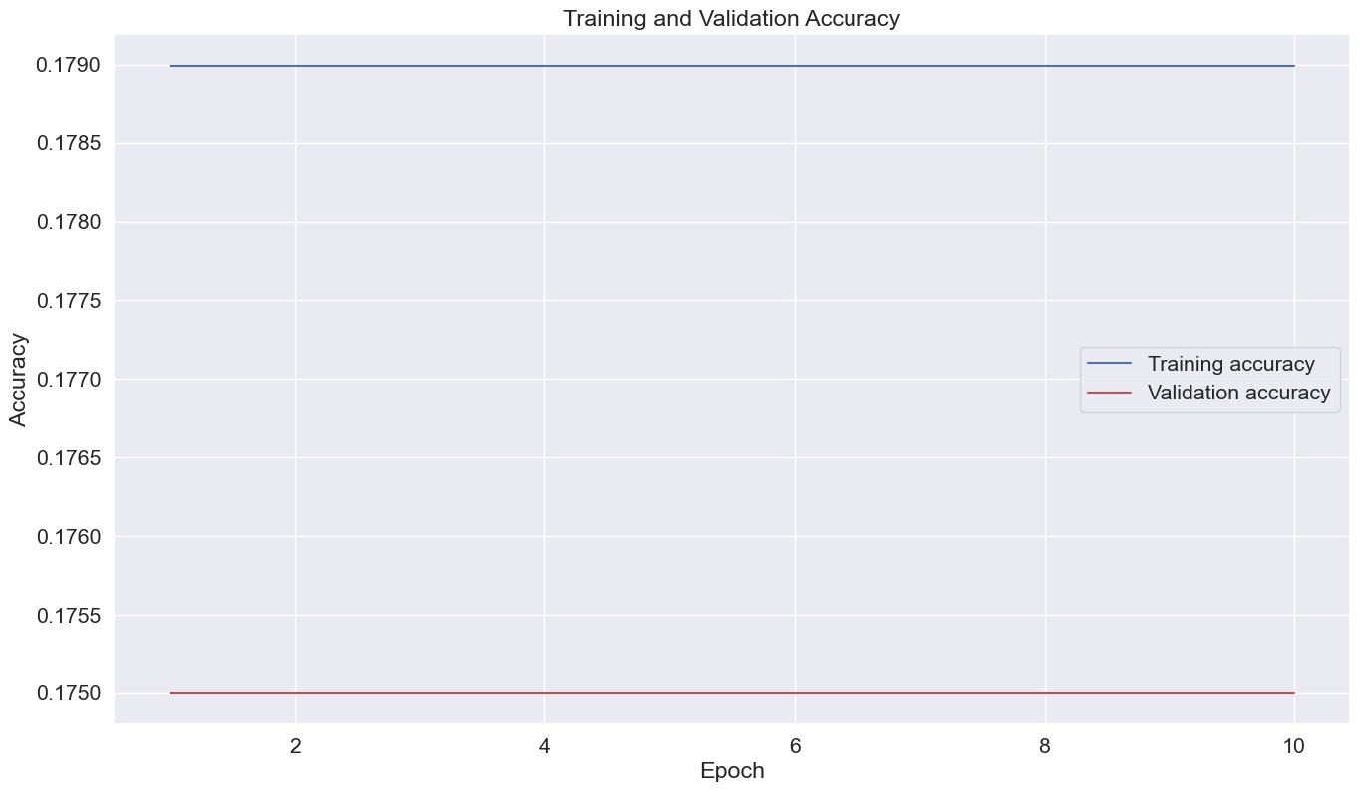

Figure 1: Training and validation accuracy plot

* **Loss over Epochs:** Showing the training loss and validation loss on a plot beginning with 10 epochs. Continuously drop connected with loss suggests the model is converging while disturbances, or worse, an increase in validation loss can be attributed to problems such as overfitting and others.

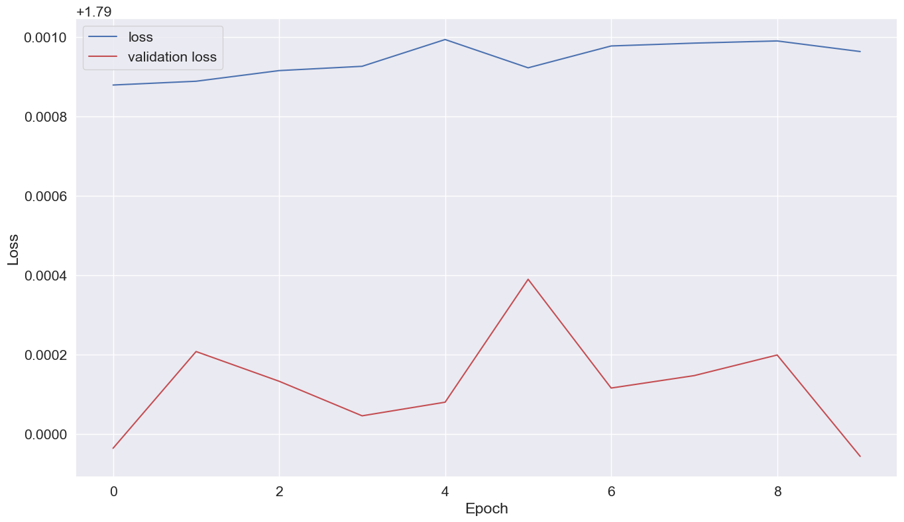

Figure 2: Training loss and validation loss plot

Such visualizations represent a critical source of information on the training process and are used to correct biases or other errors and make the model more efficient. When the actions are being regarded, an expert will know if more epochs are needed, or the learning rate should be adjusted, or some other changes are required to make the model more precise and helpful.

# **Results and Analysis**

Here, the performance of the deep learning model on the test set and the analysis of its training and validation performance is shown. Furthermore, it describes the confusion matrix that gives the model capability to predict each class respectively and visualizations to demonstrate the outcomes.

## **Evaluation of Model Performance**

After performing 10 epochs in training, the model was tested on the test set, in order to assess how it did. The test set contained images from each of the six categories: structure, leave, venture out, and cross the street. When it comes to the model's final testing accuracy, it serves as a good gauge of how efficient the model has been in putting the images in these categories.

* **Final Training Accuracy:** The model achieved an accuracy score of 0.179 (or around 17.9%) at the 30th epoch of training on the training set. These plots reflect the frequency of a specific class being detected and correctly classified during the training stage.
* **Final Validation Accuracy:** The actuality on the violations set was 0.175 (approximately 17.5%). The numerous stands for the ability of the model to do well on the test data, which haven't been utilized during the training, and hence, is an indicator of the generalized application of the model.

## **Discussion of Training and Validation Accuracy**

The training and validation accuracy seen on the 10 epoch corroborates the subpar performance in which there is room for improvement. undefined

* **Insufficient Training Time:** Learning consistent patterns for a model at ten epochs might be too shallow.
* **Lack of Data Augmentation:** In the absence of data augmentation, the model might not have been exposed to oscillating variability during the training process, as a result, the model would have the minimal generalization capabilities.
* **Model Complexity:** The individual model design could be overly complicated and then the data might be overwhelmed with excessively fitting the training results.

Learning Rate and Hyperparameters: The choice of learning rate or other hyperparameters, if deemed unsatisfactory, would be tuned for optimization.

# **Analysis of the Confusion Matrix**

The confusion matrix displays complete statistics about each class, with which more thorough insights into the model's performance are gained. It is measuring how precisely the machines are performing; that means correct class labels vs. the predicted ones therefore the machine learning model is making errors.

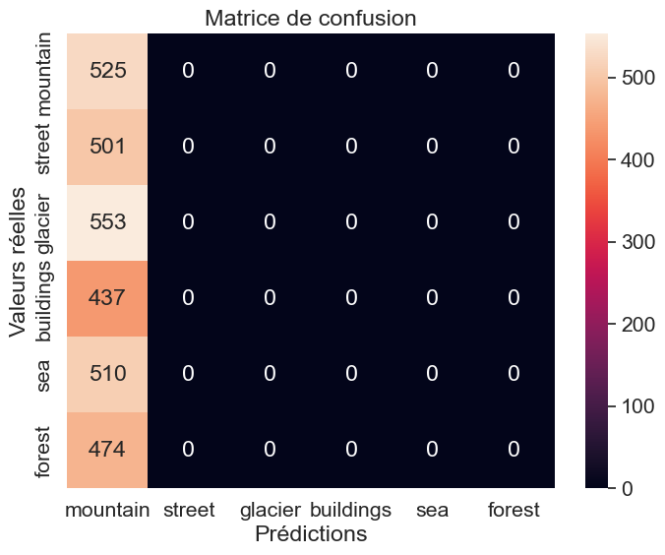

The confusion matrix shows the portion of each class into which correct and incorrect predicts are distributed. Patterns of misclassification and later possible improvements can be easily found and sorted out. Such cases as a particular class exhibits a high number of misclassifications may imply that the model is relying on insufficient amounts of training data or the need to consider different architectures.

## **Data exploration of the images:**

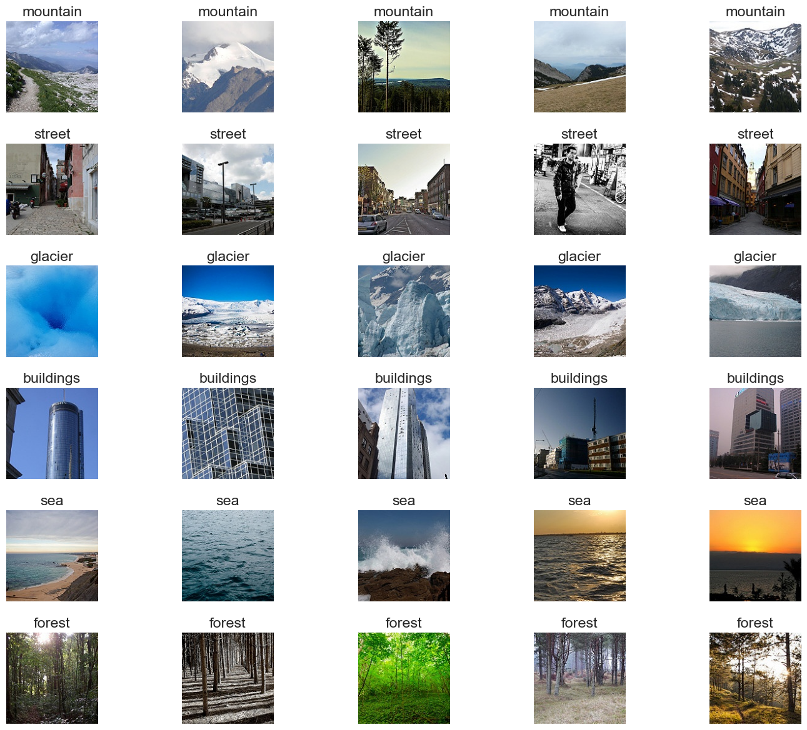

# **Industry Applications of Deep Learning**

Deep learning has had a profound effect on many industries, enabling the creation of groundbreaking solutions to various challenges. It processes the extra data which is harder for human brain to grasp as well, thus giving birth to applications that revolutionize different industries. The next section will talk about the ongoing use and main prospects of deep learning technologies and will specify some cases from healthcare, transportation and security.

## **Healthcare**

Healthcare industry is the one that has been transformed with deep learning in medical imaging and diagnosis. Convolutional neural networks (CNNs) have been proven to be deeply involved in the medical image analysis, which can assist clinicians to diagnose abnormalities more accurate than using only the instrument (Cheng et al., 2020). One instance that can be used is the field of deep learning in cancer detection. In this area, algorithms can detect tumors as well as any irregularities that might have escaped human eye beforehand (Ma et al., 2021). Deep learning is used in genomics and drug discovery as well where it can be useful to analyze big amounts of biological data and to detect new insights.

## **Transportation**

Deep learning forms a vital part in the transportation sector, but notably in driverless driving and traffic monitoring. Autonomous driving is an approach that uses the learning abilities of artificial neural networks to process sensor data, recognize obstacles, and execute driving operations simultaneously (Han et al., 2018). CNNs acknowledge road signs, pedestrians, and other vehicles at the intersections, which keeps the roads safe for drivers. Besides autonomous driving, deep learning finds applications in traffic monitoring and prediction, where it is capable of analyzing different traffic patterns to optimize the performance of the traffic system and decrease the congestion associated with it. (Gu et al., 2019).

## **Security**

In the security sector of course deep learning is the key technology that is applied for the surveillance and threat detection. The use of processes that are powered by deep learning is pursued to detect any suspecious activities which occur in real-time so as to allow a reaction of security personnel to a threat that is potential (Zeng et al., 2021). The airports and hight risk venues now are guarded by facial recognition systems which are powered by deep learning to recognize attendees and this act helps to prevent access of unauthorized people (Xu et al., 2020). Cybersecurity is another field where deep learning plays a role, the phenomenon where deep learning is used to detect anomalies and identify potential cyber threats in large scale networks.

## **Potential Applications**

Deep learning systems have been a primary mover in these industries, with more added benefits expected to come shortly. In medical settings, the AI technology of deep learning can be used in personalized medicine where the algorithms are fed with patient data to help them develop treatment recommendations based on each patient’s health condition. In the transport sphere, deep learning could move it to the beginnings of the next step eliminating any gaps and increasing road operating efficiency. Deep learning could become a standalone technology in cybersecurity to predict and prevent the breaches through historical data analysis and by early warning signals.

Deep learning has created these new doors in many industries and still finds ways to provide breakthrough solution and trigger huge progress at the same time. If technology keeps advancing itself, its use in every field would be doubtless manifested, thus promoting more social change.

# **Future Developments and Recommendations**

## **Current Limitations in Deep Learning Models**

Deep learning models have several limitations that researchers and practitioners continue to address:

* **Data Dependency:** Deep learning models require lots of high-quality data, which is often extremely hard and expensive to label and tag. Acquiring such data sets is likely making difficulties e.g. in specific fields or when dealing with data that needs to be confidential (Cheng et al., 2020). As well as this data-driven dependency, we see a threat to privacy and information security issues.
* **Computational Complexity:** Educating Deep Learning models especially bigger ones means providing a lot of resources for their implementation. It, hence, partly limits smaller research units or and one-man teams in their possession or use, would increase energy consumption, becoming negative factor for the world environmental problems (Han et al., 2018).
* **Generalization and Overfitting:** The deep networks tend to be trained on limited data and as such, can get to a point in which they perform poorly on data that they are not trained on. Here, biased datasets or those with limited samples are more challenging while training (Gu et al., 2019).
* **Interpretability and Explainability:** Frequently, the systems that are based on the brain-inspired cognition as well as deep learning models which involved complex architectures function in the way that cannot be clearly explained, meaning that it is hard to understand their decision-making process. Such non-transparency of the model may be just a bottleneck in critical decisions like for instance healthcare or security, i.e. atomic field of human lives (Ma et al., 2021).

## **Potential Solutions and Future Trends**

To address these limitations, researchers are exploring several potential solutions and future trends in deep learning:

* **Data Augmentation and Synthetic Data:** Data augmentation approaches like rotation, flipping and skewing can help in larger dataset variety. Also, this can reduce model overfitting. Besides synthetic data generation, involving manufacturing of more diverse sampling data through techniques like Generative Adversarial Networks (GANs), helps too (Zeng et al., 2021).
* **Transfer Learning and Pre-Trained Models:** Transfer learning allows models to draw from a shared pool of knowledge and the need to gather training data is made redundant. This may be a very efficient method in the case of limited sample measurements (Xu et al., 2020).
* **Explainable AI (XAI):** The interpretability of deep learning models was the subject of more studies and the scales were becoming more multi-faceted. Methods like Grad-CAM, LIME, and SHAP are here purported to serve the purpose of shedding more light on how models come to a decision, and hence improve the confidence and transparency of the system design (Petrovska et al., 2020).
* **Efficient Model Architectures:** Researchers are exploring various archetypes of models such as the simplification and normalization which in turn improve the efficiency, thereby reducing the complexity of the computation and the energy required. Methods like model compression, quantization, as well as, and knowledge distillation provide an avenue to generate thinner networks without compromising performance (Zhang et al., 2019).

## **Suggestions for Further Research and Improvements**

Given these trends and challenges, several areas offer opportunities for further research and improvements:

* **Robustness and Security:** The study of techniques to boost the hardness of deep learning models towards malicious attacks and unforeseen input variation is important in enhancing trustworthiness of these models in safety-critical functions (Cheng et al., 2020).
* **Continual Learning and Adaptability:** Amidst ongoing research, the construction of models that can learn dynamically and adjust to unexpected data inputs without reaching state of forgetfulness is regarded as an issue that requires further attention (Gu et al., 2019).
* **Ethics and Fairness:** With the rise of deep learning, the concern of ethics is now a major issue and, hence, guaranteeing fairness in the machine learning predictions is much more important. Developing bias mitigation methods and ethical AI protocols among researchers is imminent (Ma et al., 2021).

# **Conclusion**

This project is about the stance of deep learning for image scene classification. It is based on a dataset which is referred to as “Intel Image Classification” that includes images for nature scenes in different sets and differs from other datasets. The core objective was to build a Convolutional Neural Network (CNN) that could accurately classify these images into one of six categories: the building, the woods, a glacier, mountain, sea or street view.

The main thing we have got from this research is that the neural network-based model was able to learn to some degree from the data but the overall accuracy was constrained, thus improvement can be made. The last training accuracy and main validation accuracy were both lower than 18%, meaning that the model is prone to reduced performance in the prediction areas and potential overfitting. These findings support the need of further executing the network achieving, advancing the training, and using the data enlargement to raise the accuracy.

The confusion matrix was used to recommend regions where the model was underperforming and take into account special kind of errors. This gave us the opportunity to revise the model during its next edition, considering priorities for improving precision in specific groups.

The constraints perceived are not a hindrance for investigating deeper into this field although deep learning-based classification of images is established. The low accuracy levels imply several opportunities for growth such as: changing the hyper parameters, implementing data augmentation in depth or exploiting alternative model structures.

With respect to implications for future production, the following possibilities may be worth looking into. Control experts could come with a transfer learning approach using pre-trained models which may augment finesse only on minimum training data. Besides, by using explainable AI methods, even more transparency around how the models make inferences may be possible, thereby, tackling problems of overfitting and misclassification.

# **References**

* Intel Image Classification. (n.d.). Retrieved from www.kaggle.com website: <https://www.kaggle.com/datasets/puneet6060/intel-image-classification>
* Cheng, G., Xie, X., Han, J., Guo, L., & Xia, G. S. (2020). Remote sensing image scene classification meets deep learning: Challenges, methods, benchmarks, and opportunities. *IEEE Journal of Selected Topics in Applied Earth Observations and Remote Sensing*, 13, 3735-3756.
* Han, W., Feng, R., Wang, L., & Cheng, Y. (2018). A semi-supervised generative framework with deep learning features for high-resolution remote sensing image scene classification. *ISPRS Journal of Photogrammetry and Remote Sensing*, 145, 23-43.
* Ma, A., Wan, Y., Zhong, Y., Wang, J., & Zhang, L. (2021). SceneNet: Remote sensing scene classification deep learning network using multi-objective neural evolution architecture search. *ISPRS Journal of Photogrammetry and Remote Sensing*, 172, 171-188.
* Gu, Y., Wang, Y., & Li, Y. (2019). A survey on deep learning-driven remote sensing image scene understanding: Scene classification, scene retrieval, and scene-guided object detection. *Applied Sciences*, 9(10), 2110. <https://doi.org/10.3390/app9102110>
* Petrovska, B., Zdravevski, E., Lameski, P., Corizzo, R., Štajduhar, I., & Lerga, J. (2020). Deep learning for feature extraction in remote sensing: A case study of aerial scene classification. *Sensors*, 20(14), 3906. <https://doi.org/10.3390/s20143906>
* Xu, X., Chen, Y., Zhang, J., Chen, Y., Anandhan, P., & Manickam, A. (2020). A novel approach for scene classification from remote sensing images using deep learning methods. *European Journal of Remote Sensing*, 54(sup2), 383–395. <https://doi.org/10.1080/22797254.2020.1790995>
* Zeng, D., Liao, M., Tavakolian, M., Guo, Y., Zhou, B., Hu, D., … Liu, L. (2021). Deep learning for scene classification: A survey. Retrieved from <https://arxiv.org/pdf/2101.10531>
* Zhang, W., Tang, P., & Zhao, L. (2019). Remote sensing image scene classification using CNN-CapsNet. *Remote Sensing*, 11(5), 494. <https://doi.org/10.3390/rs11050494>

CHANDRA SHEKAR REDDY BOREDDY

ID : 811297636